**AIR QUALITY MONITORING SYSTEM**

**Introduction**

Air quality monitoring is the process of measuring and assessing the quality of the air in a specific location to determine the concentration of various air pollutants and pollutants that can impact human health and the environment. This monitoring is essential for understanding air pollution levels, identifying sources of pollution, and implementing strategies to mitigate air quality issues.The Air Quality Monitoring System using Internet of Things was developed to bring awareness to public. It is not only just for people residing near mines, smelting and other gas pollution industries,but also can be implemented to those who are living in a high population growth area, technological development area, urbanization and injudicious planning area without due regard to sustainable which might expose to a variety of pollutants.

**Project definition**

The primary purpose of an air quality monitoring based on the equipment and systems created is to monitor the air pollution and to distinguish between areas where pollutant levels violate an ambient air quality standard and areas where they do not.As health-based ambient air quality standards are set at level of pollutant concentrations that result in adverse impacts on human health, evidence of levels exceeding an ambient air quality standard in an area requires a public air quality agency to mitigate the corresponding pollutant. This safety equipment has become a compulsory in every building especially in industrial area in order to be a aware of the air quality level and avoid the hazardous area.

**Objectives**

The main objective of the air quality networks is to record the concentration levels of atmospheric pollutants in order to define air quality levels and establish action plans if high levels of contamination are detected and these are the other objectives such as Locating contamination problem areas and understanding their space time changes,Complying with atmospheric air protection legislation,Obtaining the necessary information to define Action Plans as stipulated by European directives or other international regulations if alert thresholds are breached, Informing citizens regarding local air quality status.

**Project design**

The development of this system via XAMPP platform allows the air quality level in parts per million data to be stored in an online database, thus allowing the public to continuously monitor the air quality level and avoid themselves to be exposed rapidly to these harmful gases. The developed hardware system consists of the MQ135 gas sensor. The gas sensor is able to sense the present of gases through the chemical reaction when the gases flows close to the sensor. The reading of air quality level appears on LCD. There are two mains part of the design which are hardware design and software design.

**Components required for Hardware implementation**

**Gas Sensor**

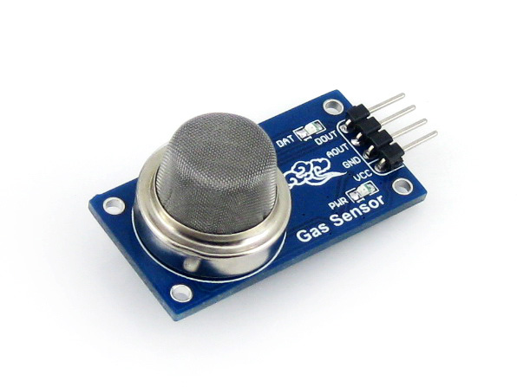

The MQ135 sensor's versatility allows it to be used for applications such as indoor air quality monitoring, gas leakage detection, and environmental sensing.The measuring range is 10 To 1000 Ppm for gas sensor.The gas sensor module consists of a steel exoskeleton under which a sensing element is housed. This sensing element is subjected to current through connecting leads. This current is known as heating current through it, the gases coming close to the sensing element get ionized and are absorbed by the sensing element.The MQ-135 Gas sensor can detect gases like Ammonia, sulfur, Benzene, CO2, and other harmful gases and smoke. Similar to other MQ series gas sensor, this sensor also has a digital and analog output pin. When the level of these gases go beyond a threshold limit in the air the digital pin goes high.

**ARDUINO UNO**

The Arduino UNO board is mostly used by the beginners that can use in electronics project and to do the programming in this board.The board has regular innovation and a bug fix in the design of the board to make the board suitable for the project.Arduino UNO is a microcontroller board which is based on the ATmega328P. It consists 14 digital input/output pins (of which 6 can be used as PWM outputs),6 analog inputs, a 16 MHz ceramic resonator, a USB connection, a power jack, an ICSP header and a reset button.Arduino consists of both a physical programmable circuit board and a piece of software, or IDE that runs on your computer, used to write and upload computer code to the physical board. It uses a variant of the C++ programming language. The code were written in C++ with an addition of special methods and functions with it.These are one of the most common Arduino boards that are available, and it has some user-friendly features, including large pitched sockets for connecting to external devices, an onboard LED, inbuilt power handling and a large USB connector for connecting to a PC system.

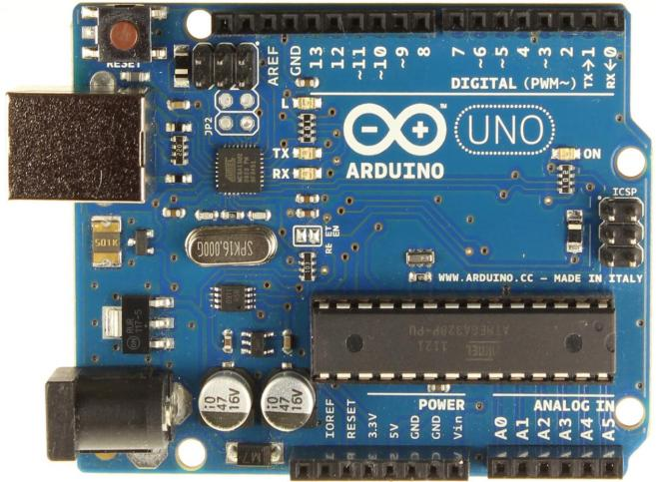

**LCD**

It is an electronic display device that operates by applying a varying electric voltage to a layer of [liquid crystal](https://www.britannica.com/science/liquid-crystal), thereby [inducing](https://www.britannica.com/dictionary/inducing) changes in its optical properties. These are commonly used for portable electronic games, as viewfinders for digital cameras and camcorders, in video projection systems, for electronic billboards, as monitors for computers, and in flat-panel televisions.It is a type of flat panel display which uses liquid crystals in its primary form of operation. LEDs have a large and varying set of use cases for consumers and businesses, as they can be commonly found in smartphones, televisions, computer monitors and instrument panels.A display is made up of millions of [pixels](https://www.techtarget.com/whatis/definition/pixel).

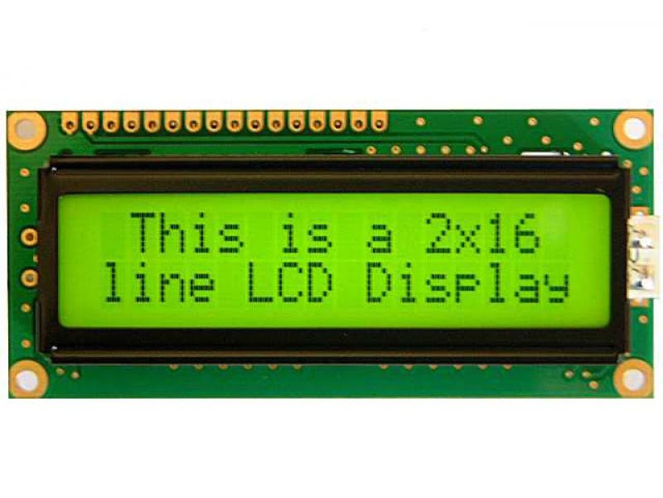

**Communication Module**

The communication module is responsible for transmitting data from the microcontroller to the cloud server. Communication modules can use various wireless technologies such as Wi-Fi, Bluetooth, or cellular networks.

**Cloud Server**

The cloud server is a centralized platform for storing, analyzing, and sharing air quality data. It collects data from the communication module and stores it in a database. The cloud server also provides web and mobile applications for users to access the data.

**Data sharing platform**



XAMPP is open-source cross-platform web server software stack package which is developed by Apache Friends.It consists of the Apache HTTP Server,MariaDB database, and interpreters that incorporate Hypertext Preprocessor and Perl Programming Language scripts.It allows this website to be initially tested before they are uploaded to a remote web server or computer.An additional tool to this software is a password feature that protects the most crucial parts of the package.

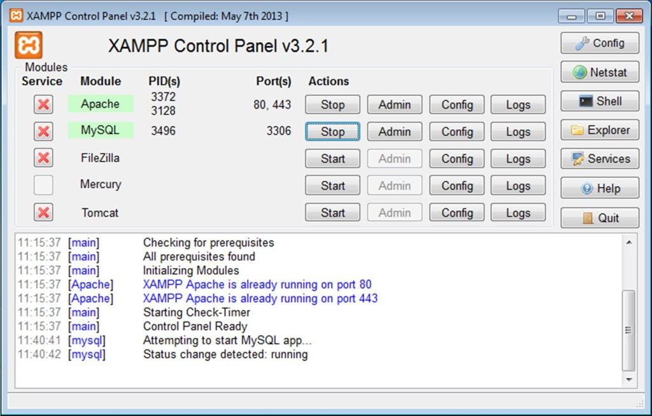

It is established as a short-range transmission technology,which has a very restricted coverage and hence it cannot support the communication needs of a large number of air quality sensors spread throughout a large area. To overcome this issues, low power wide area technology, a kind of Machine-to-Machine communication, may be used. It is purpose-built to offer ubiquitous coverage, low energy consumption, and cheap prices for devices that transmit and receive messages with restricted data rates on a somewhat regular basis. In general, an LPWA network may give suburban and rural coverage, and a typical urban coverage.

### Sensing layer

This layer performs the primary functions of the air quality monitoring system, that uses this technology.These nodes that monitor air quality are battery-powered and widely dispersed throughout a large area of the United States. Consequently, these nodes are able to collect vast amounts of data on air quality.

### Network layer

An LPWA network which is based on IEEE 802.15.4 that connects the monitoring nodes to the access point.Physical layer uses a unique [direct sequence spread spectrum](https://www.sciencedirect.com/topics/engineering/direct-sequence-spread-spectrum" \o "Learn more about direct sequence spread spectrum from ScienceDirect's AI-generated Topic Pages) technology with a high spreading factor to improve receiver sensitivity and hence give better coverage performance.Open-source software-defined radio is used to build the AP in our system because of its flexibility and inexpensive cost of [fast prototyping](https://www.sciencedirect.com/topics/engineering/fast-prototyping" \o "Learn more about fast prototyping from ScienceDirect's AI-generated Topic Pages).

### Application layer

Sensing data and providing interactive services to customers need application layer processing. The IoT cloud and client applications are the two parts of the system. First, the AP uses the IoT cloud's database to record the sensor nodes' air quality data. The acquired data on air quality is then consolidated, processed, and analysed in the Internet of Things cloud. Additionally, the IoT cloud provides information distribution and service development, which may be activated through [application programming interfaces](https://www.sciencedirect.com/topics/engineering/application-programming-interface" \o "Learn more about application programming interfaces from ScienceDirect's AI-generated Topic Pages) by client applications, whether it's on a laptop or a smartphone, depending on the platform. Client applications provide easy access to air quality data stored in the Internet of Things cloud.

**Conclusion**

As a conclusion, the Air Quality Monitoring System with IoT has achieved the objective that able to detect air pollution or harmful gases by using MQ135 gas sensor. It is also capable of spreading awareness of how important to know the effects of air pollution towards healthy and environment. The following objective which is to develop the monitoring system of air pollution for environmental sensing application using Internet of Things (IoT), has also been fulfilled. The entire system includes the hardware components such as the Arduino Uno microcontroller, MQ135 gas sensor, I2C LCD and NodeMCU (ESP8266) as well as the software components comprising of the Arduino IDE, XAMPP platform and SQLyog for database system.